Section A
Bahagian A

[60 marks]
[60 markah]

Answer all questions in this section.
Jawab semua soalan dalam bahagian ini.

1 Diagram 1.1 shows the name of three medicines.
Rajah 1.1 menunjukkan nama bagi tiga ubat-ubatan.
Paracetamol
Parasetamol
Barbiturate
Barbiturat
Penicillin
Penisilin

Diagram 1.1
Rajah 1.1

(a) (i) What is the type of medicine for paracetamol?
Apakah jenis ubat bagi parasetamol?

…………………………………………………………………………………………
[1 mark]

(ii) What is the function of the medicine that is stated in (a) (i)?
Apakah fungsi jenis ubat yang dinyatakan di (a) (i)?

…………………………………………………………………………………………..
[1 mark]

(b) Based on Diagram 1.1, which medicine is suitable for the sickness below?
Berdasarkan Rajah 1.1, ubat manakah yang sesuai untuk sakit di bawah?

Depression :
Kemurungan : …………………………………………………………………………........

Infection of bacteria :
Jangkitan bakteria : ………………………………………………………………………
[2 marks]

(c) Diagram 1.2 shows two different formula of cleaning agents.
Rajah 1.2 menunjukkan dua formula bagi agen pencuci yang berlainan.

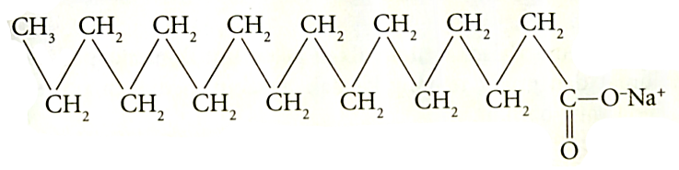
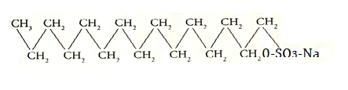

Cleaning Agent A
Agen Pencuci A
Cleaning agent B
Agen Pencuci B
Agen Pencuci B

Diagram 1.2
Rajah 1.2

(i) State the name of cleaning agent A and B.
Nyatakan nama bagi agen pencuci A dan B.

Cleaning agent A :
Agen pencuci A : ………………………………………………………………….

Cleaning agent B :
Agen pencuci B : …………………………………………………………………...
[2 marks]

(ii) Which cleaning agent that suitable use in sea water?
Agen pencuci yang manakah sesuai digunakan di dalam air laut?

…………………………………………………………………………………………
[1 mark]

(iii) Explain your answer in (c) (ii).
Terangkan jawapan anda di (c) (ii).

…………………………………………………………………………………………

…………………………………………………………………………………………

…………………………………………………………………………………………
[2 marks]

2 Diagram 2 shows elements in a group.
Rajah 2 menunjukkan unsur-unsur dalam satu kumpulan.
7
Li
3
39
K
19
23
Na
11

Table 2
Jadual 2

(a) In which group of the periodic table are these elements located?
Dalam kumpulan manakah unsur-unsur ini berada dalam Jadual Berkala?
…………………………………………………………………………………………….......
[1 mark]

(b) Write the electron arrangement for lithium atom.
Tulis susunan elektron bagi atom litium.

………………………………………………………………………………………………...
[1 mark]

(c) Lithium, sodium and potassium elements react with water to produce metal hydroxide solution and hydrogen gas.
Unsur litium, natrium dan kalium bertindak balas dengan air menghasilkan larutan logam hidroksida dan gas hidrogen.

(i) Which atom of element has the highest tendency to release electron in order to achieve octet electron arrangement?
Atom unsur yang manakah mempunyai kecenderungan yang paling tinggi untuk melepaskan elektron bagi mencapai susunan elektron oktet?

……………………………………………………………………………………….....
[1 mark]

(ii) Arrange the elements in ascending order based on the reactivity toward water.
Susun unsur-unsur itu dalam tertib menaik berdasarkan kereaktifan terhadap air.

………………………………………………………………………………………....
[1 mark]

(iii) Based on answer in (c) (i), write the chemical equation for the reaction.
Berdasarkan jawapan di (c) (i), tuliskan persamaan kimia bagi tindak balas.

………. + …… H₂O ………… + ………..
[1 mark]

(d) A piece of burning sodium is placed quickly into a gas jar containing oxygen gas.
Seketul natrium yang terbakar dimasukkan dengan cepat ke dalam balang gas yang berisi gas oksigen.

(i) State the observation of the reaction.
Nyatakan pemerhatian bagi tindak balas ini.

……………………………………………………………………………………….....
[1 mark]

(ii) State the type of the compound formed.
Nyatakan jenis sebatian yang terbentuk.

……………………………………………………………………………………….....
[1 mark]

(iii) Draw the electron arrangement of the compound in (d) (ii).
Lukiskan gambar rajah susunan elektron bagi sebatian di (d) (ii).

[2 marks]

3 (a) Diagram 3.1 shows the molecular formula of butane.
Rajah 3.1 menunjukkan formula molekul bagi butana.

C₄H₁₀

Diagram 3.1
Rajah 3.1

- What is the meaning of molecular formula?
Apakah yang dimaksudkan dengan formula molekul?

…………………………………………………………………….………………….....

………………………………………………………………………………………......
[1 mark]

- Calculate the molar mass of butane.
Hitungkan jisim molar bagi butana.
[Relative atomic mass; H = 1 , C = 12 ]
[Jisim atom relatif; H = 1 , C = 12 ]

[1 mark]

- Write the empirical formula of butane.
Tuliskan formula empirik bagi butana.

………………………………………………………………………………………......
[1 mark]

- Compare and contrast between molecular formula and empirical formula of butane.
Banding dan bezakan antara formula molekul dan formula empirik bagi butana.

…………………………………………………………………….…………………….

…………………………………………………………………….…………………….
[2 marks]

(b) Diagram 3.2 shows a chemical equation.
Rajah 3.2 menunjukkan satu persamaan kimia.

2KI(aq) + Pb(NO₃)₂(aq) → 2KNO₃(aq) + PbI₂(s)

2KI(ak) + Pb(NO₃)₂(ak) → 2KNO₃(ak) + PbI₂(p)

Diagram 3.2
Rajah 3.2

Based on the equation, answer the following questions;
Berdasarkan persamaan itu, jawab soalan-soalan berikut;

- State the colour of PbI₂
Nyatakan warna bagi PbI₂

…………………………………………………………………….…………………….
[1 mark]

- State the name of one reactant and one product.
Nyatakan nama bagi satu bahan tindak balas dan satu hasil tindak balas.

Reactant / Bahan tindak balas : ..........................................................................

Product / Hasil tindak balas : ..............................................................................
[1 mark]

- State the physical state of PbI₂
Nyatakan keadaan fizik bagi PbI₂

…………………………………………………………………….…………………….
[1 mark]

- In a reaction; 20 cm³ of 0.5 mol dm⁻³ Pb(NO₃)₂ has reacted. Calculate the mass of PbI₂ formed.
[Relative atomic mass : I = 127 ; Pb = 207]

Dalam suatu tindak balas; 20 cm³ Pb(NO₃)₂ 0.5 mol dm⁻³ telah bertindak balas. Hitungkan jisim PbI₂ yang terbentuk.
[Jisim atom relatif : I = 127 ; Pb = 207]

[2 marks]
4 Diagram 4 shows the apparatus set-up to study the factor that affecting the products of electrolysis of copper(II)sulphate solution.
Rajah 4 menunjukkan susunan radas bagi mengkaji faktor yang mempengaruhi hasil elektrolisis larutan kuprum(II) sulfat.

Electrode X
Elektrod X
Electrode carbon
Elektrod karbon
Copper(II) sulphate solution
Larutan kuprum(II) sulfat
Diagram 4
Rajah 4

Experiment is repeated using electrode Y to replace electrode X.
Eksperimen diulangi menggunakan elektrod Y bagi menggantikan elektrod X.

Table 4 shows the observation at electrode X and electrode Y. .
Jadual 4 menunjukkan pemerhatian pada elektrod X dan elektrod Y.

Electrode  Elektrod | Observation  Pemerhatian
X | Gas bubbles released  Gelembung gas terbebas
Y | The electrode becomes thinner  Elektrod menipis

Table 4
Jadual 4

(a) What is meant by electrolysis?
Apakah yang dimaksudkan dengan elektrolisis?

………………………………………………………………………………………………...

………………………………………………………………………………………………...
[1 mark]

(b) Suggest the electrode
Cadangkan elektrod

X :…………………………………………………………………………………………......

Y : ………………………………………………………………………………………........
[2 marks]

(c) State the name of the gas released at electrode X.
Nyatakan nama gas yang terbebas di elektrod X .

………………………………………………………………………………………….........
[1 mark]

(d) State the factor that affecting the product at the electrode Y.
Nyatakan faktor yang mempengaruhi hasil pada dan elektrod Y.

………………………………………………………………………………………….........
[1 mark]

(e) Write the half equation for the reaction occurred at
Tuliskan setengah persamaan bagi tindak balas yang berlaku pada

electrode X :
elektrod X : ......……………………………………………………………………….....

electrodeY :
elektrod Y : ......……………………………………………………………………….....
[2 marks]

(f) Compare the intensity of colour of the copper(II) sulphate solution when electrode X and electrode Y used. Explain your answer.
Bandingkan keamatan warna larutan kuprum(II) sulfat apabila elektrod X dan elektrod Y digunakan. Terangkan jawapan anda.

………………………………………………………………………………………….........

………………………………………………………………………………………….........

………………………………………………………………………………………….........

………………………………………………………………………………………….........
[2 marks]

(g) The product at cathode is copper. Give a reason for your answer.
Hasil elektrolisis pada katod ialah kuprum. Berikan satu sebab bagi jawapan anda.

…………………………………………………………………………………………..........
[1 mark]

5 Table 5 shows the information of two carbonate salts.
Jadual 5 menunjukkan maklumat tentang dua garam karbonat.

Carbonate salt  Garam karbonat | Solubility in water  Keterlarutan dalam air | Action of heat  Tindakan oleh haba
X carbonate  Karbonat X | Soluble in water  Larut dalam air | Not decomposed by heat  Tidak dapat diurai oleh haba
Y carbonate  Karbonat Y | Insoluble in water  Tidak larut dalam air | Produce residue A that is yellow when hot and white when cold and gas B that can cloud the lime water  Menghasilkan baki A yang berwarna kuning ketika panas dan putih apabila sejuk dan gas B yang boleh mengeruhkan air kapur

Table 5
Jadual 5

(a) What is meant by salt?
Apakah yang dimaksudkan dengan garam?

.................................................................................................................................

.................................................................................................................................

.................................................................................................................................
[1 mark]

(b) (i) Suggest the name of salt X carbonate.
Cadangkan nama bagi garam karbonat X.

.......................................................................................................................
[1 mark]

(ii) State two chemicals that can be used to prepare salt X.
Nyatakan dua bahan kimia yang boleh diguna untuk menyediakan garam X.

.......................................................................................................................

.......................................................................................................................
[1 mark]

(c) (i) State the name of residue A and gas B.
Nyatakan nama bagi baki A dan gas B.

Residue A / Baki A : ...........................................................................................

Gas B / Gas B : ..................................................................................................
[2 marks]

(ii) Write the chemical equation when the salt Y carbonate is heated.
Tuliskan persamaan kimia apabila garam karbonat Y dipanaskan.

.......................................................................................................................
[2 marks]

(iii) Draw the apparatus set up to carry out the experiment in (c) (ii).
Lukis susunan radas untuk menjalankan eksperimen di (c) (ii).

[2 marks]

(iv) Predict the observation when salt Y nitrate is heated.
Ramalkan pemerhatian apabila garam Y nitrat dipanaskan.

.......................................................................................................................

.......................................................................................................................

.......................................................................................................................
[2 marks]

6 Diagram 6 shows the apparatus set-up to determine the heat of precipitation for silver chloride.
Rajah 6 menunjukkan susunan alat radas untuk menentukan haba pemendakan bagi argentum klorida.

50 cm³ of 0.5 mol dm⁻³
sodium chloride solution
50 cm³ larutan natrium klorida 0.5 mol dm⁻³

50 cm³ of 0.5 mol dm⁻³
silver nitrate solution
50 cm³ larutan argentum
nitrat 0.5 mol dm⁻³

Plastic cup
Cawan plastik

Diagram 6
Rajah 6

Table 6 shows the results obtained.
Jadual 6 menunjukkan keputusan yang diperoleh.

Description  Penerangan | Temperature (⁰C)  Suhu (⁰C)
Initial temperature of silver nitrate solution  Suhu awal larutan argentum nitrat | 28.0
Initial temperature of sodium chloride solution  Suhu awal larutan natrium klorida | 28.0
The highest temperature of the mixture  Suhu tertinggi campuran | 31.5

Table 6
Jadual 6

- Why plastic cup is used in this experiment?
Mengapa cawan plastik digunakan dalam eksperimen ini?

......................................................................................................................................
[1 mark]

- The chemical equation for the precipitation of silver chloride is as follows :
Persamaan kimia bagi pemendakan argentum nitrat adalah seperti berikut :

AgNO₃ + NaCl → AgCl + NaNO₃

Calculate,
Hitungkan,

(i) the heat change in the reaction
[Specific heat capacity, c = 4.2 J g⁻¹ ⁰C⁻¹ ; Density of solution = 1 g cm⁻³]

perubahan haba dalam tindak balas itu
[Muatan haba tentu, c = 4.2 J g⁻¹ ⁰C⁻¹ ; Ketumpatan larutan = 1 g cm⁻³]

[1 mark]

(ii) the heat of precipitation of silver chloride
haba pemendakan bagi argentum klorida

[3 marks]

- Draw the energy level diagram for the reaction.
Lukiskan gambar rajah aras tenaga bagi tindak balas itu.

[3 marks]

- The experiment is repeated by using 50 cm³ of 0.5 mol dm⁻³ potassium chloride solution to replace the sodium chloride solution.
Eksperimen itu diulangi dengan menggunakan 50 cm³ larutan kalium klorida 0.5 mol dm⁻³ menggantikan larutan natrium klorida.

(i) Predict the value of heat of precipitation for this experiment.
Ramalkan nilai haba pemendakan bagi eksperimen ini.

.............................................................................................................................
[1 mark]

(ii) Explain your answer in (d) (i).
Terangkan jawapan anda di (d) (i).

.............................................................................................................................

.............................................................................................................................
[2 marks]

Section B
Bahagian B

[20 marks]
[20 markah]

Answer any one question from this section.
Jawab mana-mana satu soalan daripada bahagian ini.

7 (a) Food stored in a refrigerator last longer than food stored in a kitchen cabinet.
Explain why.
Makanan yang disimpan di dalam peti sejuk tahan lebih lama daripada makanan yang disimpan dalam kabinet dapur. Terangkan mengapa.
[4 marks]

(b) Table 7 shows the information for three sets of experiment to investigate factors affecting the rate of reaction between calcium carbonate and hydrochloric acid.
Jadual 7 menunjukkan maklumat bagi tiga set eksperimen untuk menyiasat faktor-faktor yang mempengaruhi kadar tindak balas antara kalsium karbonat dengan asid
hidroklorik.

Experiment  Eksperimen | Reactants  Bahan tindak balas |  | Time taken to collect 40 cm³ of carbon dioxide gas (s)  Masa yang diambil untuk mengumpul 40 cm³ gas karbon dioksida (s)
Set I | Excess calcium Carbonate powder  Serbuk kalsium karbonat berlebihan | 50 cm³ of 1.0 mol dm⁻³ hydrochloric acid  50 cm³ asid hidroklorik 1.0 mol dm⁻³ | 33
Set II | Excess calcium carbonate chip  Ketulan kalsium karbonat berlebihan | 50 cm³ of 1.0 mol dm⁻³ hydrochloric acid  50 cm³ asid hidroklorik 1.0 mol dm⁻³ | 45
Set III | Excess calcium carbonate powder  Serbuk kalsium karbonat berlebihan | 25 cm³ of 2.0 mol dm⁻³ hydrochloric acid  25 cm³ asid hidroklorik 2.0 mol dm⁻³ | 25

Table 7
Jadual 7

(i) Write the chemical equation for the reaction between calcium carbonate and hydrochloric acid.
Calculate the maximum volume of carbon dioxide gas produced in Set I.
[Given that the molar volume of gas is 24 dm³ mol⁻¹ at room conditions]

Tuliskan persamaan kimia bagi tindak balas antara kalsium karbonat dengan asid hidroklorik. Hitungkan isipadu maksimum bagi gas karbon dioksida yang terhasil dalam Set I.
[Diberi isipadu molar bagi gas ialah 24 dm³ mol⁻¹ pada keadaan bilik]
[5 marks]

(ii) Calculate the average rate of reaction for Set II.
Hitungkan kadar tindak balas purata bagi Set II.
[1 mark]

(iii) Based on the information in Table 7, compare the rate of reaction between
- Set I and Set II
- Set I and Set III
By using the collision theory, explain your answers.

Berdasarkan maklumat dalam Jadual 7, bandingkan kadar tindak balas antara
- Set I dan Set II
- Set I dan Set III
Dengan menggunakan teori perlanggaran, terangkan jawapan anda.
[10 marks]

8 (a) Diagram 8 shows the apparatus set-up for redox reactions involving electron transfer at a distance.
Rajah 8 menunjukkan susunan radas bagi tindak balas redoks yang melibatkan pemindahan elektron pada satu jarak.

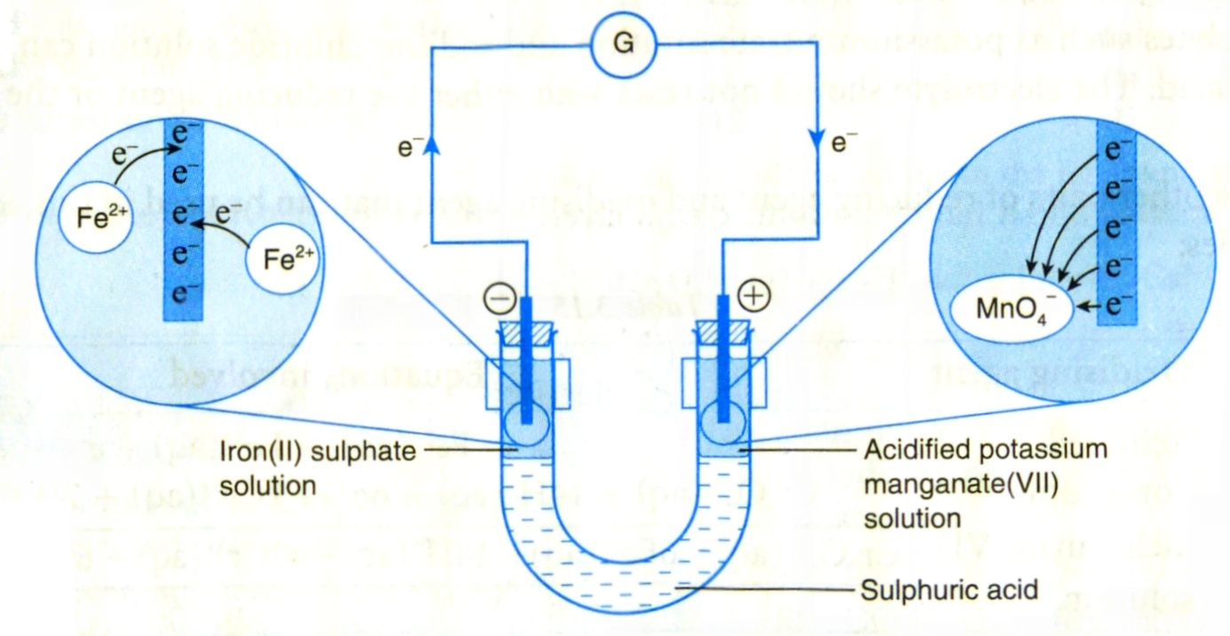
Acidified potassium manganate(VII) solution
Larutan kalium manganat(VII) berasid
Iron(II) sulphate solution
Larutan ferum(II) sulfat
Dilute sulphuric acid
Asid sulfurik cair

Diagram 8
Rajah 8

Based on Diagram 8, explain how the transfer of electron occurred.
In your description state the substance that undergoes oxidation and reduction.
Berdasarkan Rajah 8, terangkan bagaimana pemindahan elektron itu berlaku.
Dalam penerangan anda nyatakan bahan yang mengalami pengoksidaan dan penurunan.
[4 marks]

(b) The Prime Minister of Malaysia, YAB Tun Dr.Mahathir Bin Mohamad had visited to Japan on 10-12 June 2018. In his visit, he has suggested to produce national car 2.0.
You are selected to work at the car factory.
Suggest the way to control the rusting and give a reason for your answer of the following parts of cars:
- Gear and engine
- Car body
- Tire rim

Perdana Menteri Malaysia, YAB Tun Dr. Mahathir Bin Mohamad telah membuat lawatan ke negara Jepun pada 10-12 Jun 2018. Dalam lawatan itu beliau telah mencadangkan untuk mengeluarkan kereta nasional 2.0.
Anda telah dipilih untuk bekerja di kilang kereta itu.
Cadangkan cara untuk mengawal pengaratan dan berikan satu sebab bagi jawapan anda pada bahagian-bahagian kereta berikut:
- Gear dan enjin
- Badan kereta
- Rim tayar
[6 marks]

(c) Table 8 shows the apparatus set-up and observation of two set of experiments, Set I and Set II for the reaction between metal X and metal Y with copper(II) oxide.

Jadual 8 menunjukkan susunan radas dan pemerhatian dua set eksperimen, Set I dan Set II bagi tindak balas antara logam X dan logam Y dengan kuprum(II) oksida.

Set | Apparatus set up  Susunan radas | Observation  Pemerhatian
I | Mixture of metal X and copper(II) oxide.  Campuran logam X dan  Kuprum(II) oksida  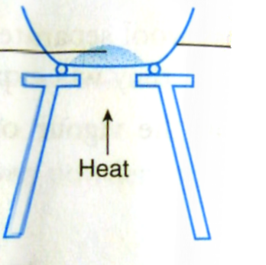 | A glow spreads to the whole mixture.Black solid change to brown solid.  Baraan merebak ke seluruhan campuran.  Pepejal hitam bertukar ke pepejal perang
II | Mixture of metal Y and copper(II) oxide.  Campuran logam Y dan Kuprum(II) oksida | No change  Tiada perubahan

Table 8
Jadual 8

Suggest metal X and metal Y.
Explain the observation for set I and set II. In your answer state
- the substance that is oxidised
- the substance that is reduced
- oxidising agent and reducing
- change in oxidation number of copper.

Cadangkan logam X dan logam Y.
Terangkan pemerhatian bagi set I dan set II. Dalam jawapan anda nyatakan
- bahan yang dioksidakan
- bahan yang diturunkan
- agen pengoksidaan dan agen penurunan.
- perubahan nombor pengoksidaan kuprum.
[10 marks]

Section C
Bahagian C

[20 marks]
[20 markah]

Answer any one question from this section.
Jawab mana-mana satu soalan daripada bahagian ini.

9 (a) Explain the following situation;
- A farmer was treating the soil with limestone powder.
- A student uses vinegar to reduce the pain by insect bites.

Terangkan situasi berikut;
- Seorang petani telah merawat tanahnya dengan menabur serbuk batu kapur.
- Seorang pelajar menggunakan cuka untuk mengurangkan kesakitan oleh gigitan serangga.
[4 marks]

(b) Table 9 shows the apparatus set-up and observation of two experiments.
Jadual 9 menunjukkan susunan radas dan pemerhatian bagi dua eksperimen.

Experiment  Eksperimen | Apparatus set-up  Susunan radas | Observation  Pemerhatian
I | 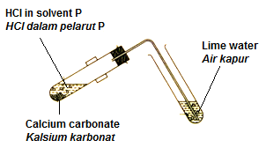 | Colourless gas releases  Gas tak berwarna terbebas  Lime water turns cloudy  Air kapur menjadi keruh
II | 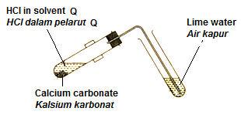 | No change  Tiada perubahan
Table 9
Jadual 9

Based on Table 9,
Berdasarkan jadual 9,

- Suggest solvent P and solvent Q
Cadang pelarut P dan pelarut Q
[2 marks]

- Explain the differences in the observations for both of experiment.
Write one chemical equation involved.
Terangkan perbezaan dalam pemerhatian bagi kedua-dua eksperimen.
Tulis satu persamaan kimia yang terlibat.
[4 marks]

(c) You are supplied with following apparatus and materials:
Anda dibekalkan dengan radas dan bahan kimia berikut:

- 0.1 mol dm⁻³ acid R
Asid R 0.1 mol dm⁻³

- x mol dm⁻³ alkali S
Alkali S x mol dm⁻³

- Burette
Buret

- 25 cm³ pipette
Pipet 25 cm³

- Pipette filler
Pengisi pipet

- Retort stand and clamp
Kaki retort dan pengapit

- White tile
Jubin putih

- 250 cm³ conical flask
Kelalang kon 250 cm³

- Phenolpthalein
Fenolftalein

By using the names of acid R and alkali S, describe an experiment to determine the value of x. In your description, write the chemical equation and show the steps of calculation involved.

Dengan menggunakan asid R dan alkali S yang dinamakan, huraikan satu eksperimen untuk menentukan nilai x. Dalam huraian anda, tuliskan persamaan kimia dan tunjukkan langkah-langkah penghitungan yang terlibat.
[10 marks]
10 Diagram 10.1 shows five structural formula of carbon compound.
Rajah 10.1 menunjukkan lima formula struktur bagi sebatian karbon.

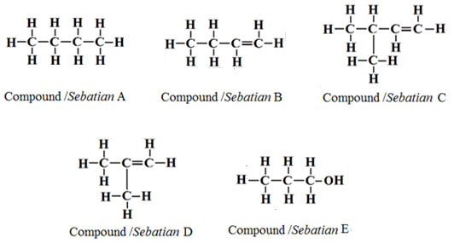

Diagram 10.1
Rajah 10.1

- Choose any one of the compound in Diagram 10.1, state the products formed when the compound burn completely in excess oxygen gas.
Write the chemical equation involve.
Pilih mana-mana satu sebatian dalam Rajah 10.1, Nyatakan hasil-hasil yang terbentuk apabila sebatian itu terbakar dengan lengkap dalam gas oksigen berlebihan.
Tuliskan persamaan kimia yang terlibat.
[3 marks]

- State the name of two compounds in Diagram 10.1 that are isomer. Explain your answer.
Nyatakan nama dua sebatian dalam Rajah 10.1 adalah isomer. Terangkan jawapan anda.
[3 marks]

- Between compound A and B, which compound produced more soot?
Explain your answer.
[RAM, C=12, H=1]
Antara sebatian A dan B, manakah sebatian yang menghasilkan lebih jelaga?
Terangkan jawapan anda.
[JAR, C=12, H=1]
[4 marks]

- Diagram 10.2 shows the reaction between compound E and carboxylic acid. Rajah 10.2 menunjukkan tindak balas antara sebatian E dengan asid karboksilik.
Compound E + Carboxylic acid → ester

Sebatian E + Asid karboksilik → ester

Diagram 10.2
Rajah 10.2

State the name an example of a member of carboxylic acid and state the name of ester that formed when the named carboxylic acid react with compound E.
Describe an experiment to produce ester in laboratory by using compound E and carboxylic acid that you have named.
Write the chemical equation involved.

Nyatakan nama satu contoh ahli bagi asid karboksilik dan nyatakan nama ester yang terbentuk apabila asid karboksilik yang dinamakan bertindak balas dengan sebatian E.
Huraikan satu eksperimen untuk menghasilkan ester dalam makmal dengan menggunakan sebatian E dan asid karboksilik yang telah dinamakan.
Tulis persamaan kimia yang terlibat.

[10 marks]

END OF QUESTION PAPER
KERTAS SOALAN TAMAT

